Experiment 1
Objective: Build a responsive web application for a shopping cart with registration, login, catalogue, and cart pages using CSS3 features, flex, and grid.
To implement this, we will create a shared CSS file (style.css) utilizing CSS Flexbox and Grid, along with four HTML files:
- register.html (Registration Page)
- login.html (Login Page)
- catalog.html (Product Catalogue Page)
- cart.html (Shopping Cart Page)

style.css (Common to all pages)
/* Reset and General Styles */
* {
margin: 0;
padding: 0;
box-sizing: border-box;
font-family: 'Segoe UI', Tahoma, Geneva, Verdana, sans-serif;
}

body {
background-color: #f4f6f9;
color: #333;
display: flex;
flex-direction: column;
min-height: 100vh;
}

/* Header & Navigation (Flexbox) */
header {
background-color: #1a252f;
padding: 15px 5%;
}

.navbar {
display: flex;
justify-content: space-between;
align-items: center;
flex-wrap: wrap;
}

.brand {
color: #fff;
font-size: 1.5rem;
font-weight: bold;
text-decoration: none;
}

.nav-links {
display: flex;
list-style: none;
gap: 20px;
}

.nav-links a {
color: #bdc3c7;
text-decoration: none;
font-size: 1rem;
transition: color 0.3s;
}

.nav-links a:hover, .nav-links a.active {
color: #fff;
}

/* Container */
.container {
flex: 1;
width: 90%;
max-width: 1200px;
margin: 30px auto;
}

/* Forms (Flexbox Alignment) */
.form-container {
background-color: #fff;
padding: 30px;
border-radius: 8px;
box-shadow: 0 4px 6px rgba(0,0,0,0.1);
max-width: 450px;
margin: 40px auto;
}

.form-container h2 {
margin-bottom: 20px;
color: #2c3e50;
text-align: center;
}

.form-group {
margin-bottom: 15px;
display: flex;
flex-direction: column;
}

.form-group label {
margin-bottom: 5px;
font-weight: 600;
}

.form-group input {
padding: 10px;
border: 1px solid #ccc;
border-radius: 4px;
font-size: 1rem;
}

.btn {
background-color: #3498db;
color: #fff;
padding: 10px 15px;
border: none;
border-radius: 4px;
font-size: 1rem;
cursor: pointer;
width: 100%;
transition: background-color 0.3s;
}

.btn:hover {
background-color: #2980b9;
}

.form-footer {
margin-top: 15px;
text-align: center;
font-size: 0.9rem;
}

.form-footer a {
color: #3498db;
text-decoration: none;
}

/* Catalog Grid Layout */
.catalog-grid {
display: grid;
grid-template-columns: repeat(auto-fit, minmax(250px, 1fr));
gap: 25px;
}

.product-card {
background-color: #fff;
border-radius: 8px;
box-shadow: 0 4px 6px rgba(0,0,0,0.1);
padding: 15px;
display: flex;
flex-direction: column;
justify-content: space-between;
}

.product-image {
width: 100%;
height: 180px;
background-color: #ecf0f1;
display: flex;
align-items: center;
justify-content: center;
font-size: 0.9rem;
color: #7f8c8d;
border-radius: 4px;
margin-bottom: 15px;
}

.product-info h3 {
font-size: 1.2rem;
margin-bottom: 8px;
color: #2c3e50;
}

.product-info p {
font-size: 0.9rem;
color: #7f8c8d;
margin-bottom: 12px;
}

.product-price {
font-size: 1.2rem;
font-weight: bold;
color: #e74c3c;
margin-bottom: 15px;
}

/* Cart Page Layout (Flexbox & Grid) */
.cart-layout {
display: grid;
grid-template-columns: 2fr 1fr;
gap: 30px;
}

@media (max-width: 768px) {
.cart-layout {
grid-template-columns: 1fr;
}
}

.cart-items {
background-color: #fff;
padding: 20px;
border-radius: 8px;
box-shadow: 0 4px 6px rgba(0,0,0,0.1);
}

.cart-item {
display: flex;
justify-content: space-between;
align-items: center;
border-bottom: 1px solid #ecf0f1;
padding: 15px 0;
}

.cart-item:last-child {
border-bottom: none;
}

.cart-item-info {
display: flex;
gap: 15px;
align-items: center;
}

.cart-item-img {
width: 60px;
height: 60px;
background-color: #ecf0f1;
border-radius: 4px;
}

.cart-item-details h4 {
font-size: 1rem;
color: #2c3e50;
}

.cart-item-details p {
font-size: 0.85rem;
color: #7f8c8d;
}

.cart-item-actions {
display: flex;
align-items: center;
gap: 15px;
}

.quantity-input {
width: 50px;
padding: 5px;
text-align: center;
}

.remove-btn {
background-color: #e74c3c;
color: white;
border: none;
padding: 5px 10px;
border-radius: 4px;
cursor: pointer;
}

.cart-summary {
background-color: #fff;
padding: 20px;
border-radius: 8px;
box-shadow: 0 4px 6px rgba(0,0,0,0.1);
height: fit-content;
}

.summary-row {
display: flex;
justify-content: space-between;
margin-bottom: 15px;
font-size: 1rem;
}

.summary-total {
border-top: 1px solid #ecf0f1;
padding-top: 15px;
font-size: 1.2rem;
font-weight: bold;
}

/* Footer */
footer {
background-color: #1a252f;
color: #bdc3c7;
text-align: center;
padding: 15px;
margin-top: auto;
font-size: 0.9rem;
}

- register.html (Registration Page)
<!DOCTYPE html>
<html lang="en">
<head>
<meta charset="UTF-8">
<meta name="viewport" content="width=device-width, initial-scale=1.0">
<title>Register - Shopping Cart</title>
<link rel="stylesheet" href="style.css">
</head>
<body>
<header>
<nav class="navbar">
<a href="catalog.html" class="brand">E-Shop</a>
<ul class="nav-links">
<li><a href="catalog.html">Catalog</a></li>
<li><a href="cart.html">Cart</a></li>
<li><a href="login.html">Login</a></li>
<li><a href="register.html" class="active">Register</a></li>
</ul>
</nav>
</header>

<div class="container">
<div class="form-container">
<h2>Create Account</h2>
<form action="login.html" method="GET">
<div class="form-group">
<label for="username">Full Name</label>
<input type="text" id="username" required placeholder="Enter full name">
</div>
<div class="form-group">
<label for="email">Email Address</label>
<input type="email" id="email" required placeholder="Enter email">
</div>
<div class="form-group">
<label for="password">Password</label>
<input type="password" id="password" required placeholder="Create password">
</div>
<button type="submit" class="btn">Register</button>
</form>
<div class="form-footer">
Already have an account? <a href="login.html">Login Here</a>
</div>
</div>
</div>

<footer>
&copy; 2025 E-Shop Application. All rights reserved.
</footer>
</body>
</html>

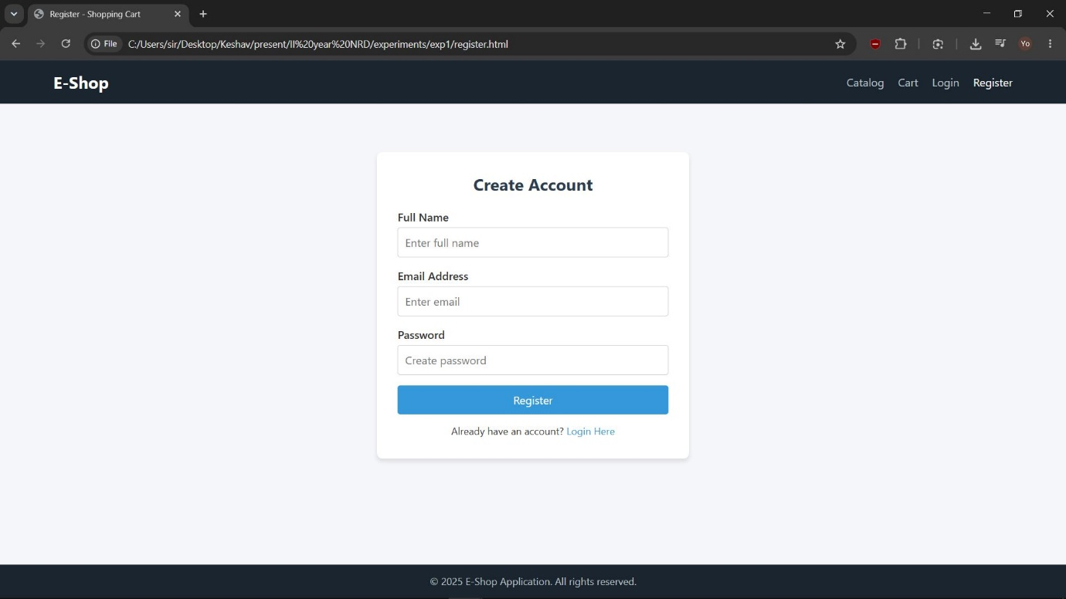

- login.html (Login Page)
<!DOCTYPE html>
<html lang="en">
<head>
<meta charset="UTF-8">
<meta name="viewport" content="width=device-width, initial-scale=1.0">
<title>Login - Shopping Cart</title>
<link rel="stylesheet" href="style.css">
</head>
<body>
<header>
<nav class="navbar">
<a href="catalog.html" class="brand">E-Shop</a>
<ul class="nav-links">
<li><a href="catalog.html">Catalog</a></li>
<li><a href="cart.html">Cart</a></li>
<li><a href="login.html" class="active">Login</a></li>
<li><a href="register.html">Register</a></li>
</ul>
</nav>
</header>

<div class="container">
<div class="form-container">
<h2>User Login</h2>
<form action="catalog.html" method="GET">
<div class="form-group">
<label for="email">Email Address</label>
<input type="email" id="email" required placeholder="Enter email">
</div>
<div class="form-group">
<label for="password">Password</label>
<input type="password" id="password" required placeholder="Enter password">
</div>
<button type="submit" class="btn">Login</button>
</form>
<div class="form-footer">
New user? <a href="register.html">Register Here</a>
</div>
</div>
</div>

<footer>
&copy; 2025 E-Shop Application. All rights reserved.
</footer>
</body>
</html>

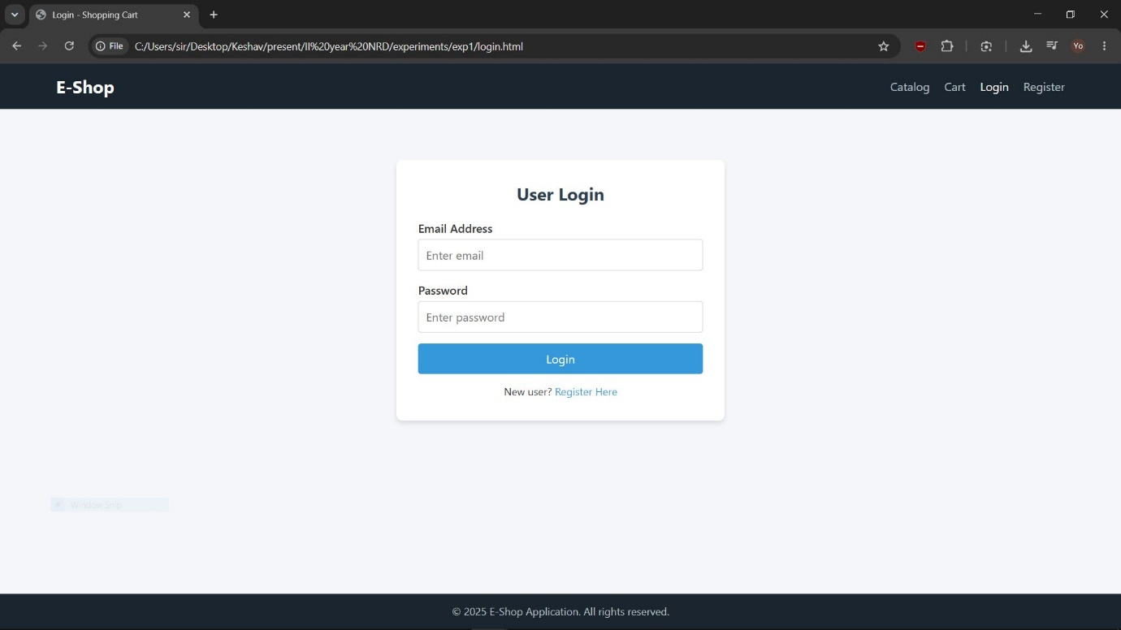

- catalog.html (Product Catalogue Page)
<!DOCTYPE html>
<html lang="en">
<head>
<meta charset="UTF-8">
<meta name="viewport" content="width=device-width, initial-scale=1.0">
<title>Catalog - Shopping Cart</title>
<link rel="stylesheet" href="style.css">
</head>
<body>
<header>
<nav class="navbar">
<a href="catalog.html" class="brand">E-Shop</a>
<ul class="nav-links">
<li><a href="catalog.html" class="active">Catalog</a></li>
<li><a href="cart.html">Cart</a></li>
<li><a href="login.html">Login</a></li>
<li><a href="register.html">Register</a></li>
</ul>
</nav>
</header>

<div class="container">
<h2 style="margin-bottom: 25px; color: #2c3e50;">Products Catalog</h2>

<div class="catalog-grid">
<!-- Product Item 1 -->
<div class="product-card">
<div class="product-image">Product Image 1</div>
<div class="product-info">
<h3>Wireless Headphones</h3>
<p>Noise-canceling over-ear wireless headphones with long battery life.</p>
</div>
<div class="product-price">$99.99</div>
<button class="btn" onclick="location.href='cart.html'">Add to Cart</button>
</div>

<!-- Product Item 2 -->
<div class="product-card">
<div class="product-image">Product Image 2</div>
<div class="product-info">
<h3>Smart Watch</h3>
<p>Water-resistant fitness tracker smart watch with heart rate monitor.</p>
</div>
<div class="product-price">$149.99</div>
<button class="btn" onclick="location.href='cart.html'">Add to Cart</button>
</div>

<!-- Product Item 3 -->
<div class="product-card">
<div class="product-image">Product Image 3</div>
<div class="product-info">
<h3>Mechanical Keyboard</h3>
<p>RGB backlit mechanical keyboard with customizable tactile switches.</p>
</div>
<div class="product-price">$89.99</div>
<button class="btn" onclick="location.href='cart.html'">Add to Cart</button>
</div>

<!-- Product Item 4 -->
<div class="product-card">
<div class="product-image">Product Image 4</div>
<div class="product-info">
<h3>Gaming Mouse</h3>
<p>Ergonomic gaming mouse featuring optical sensor and custom buttons.</p>
</div>
<div class="product-price">$49.99</div>
<button class="btn" onclick="location.href='cart.html'">Add to Cart</button>
</div>
</div>
</div>

<footer>
&copy; 2025 E-Shop Application. All rights reserved.
</footer>
</body>
</html>

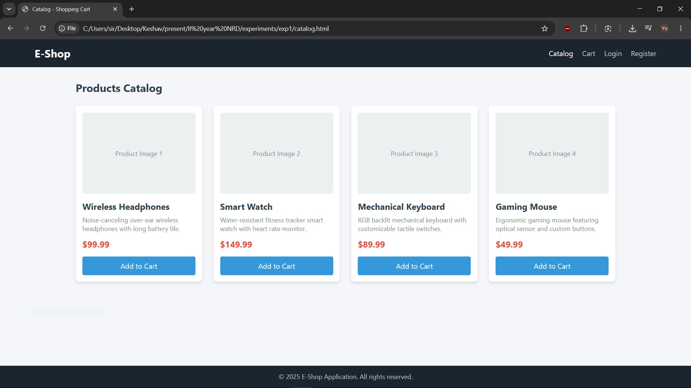

- cart.html (Shopping Cart Page)
<!DOCTYPE html>
<html lang="en">
<head>
<meta charset="UTF-8">
<meta name="viewport" content="width=device-width, initial-scale=1.0">
<title>My Cart - Shopping Cart</title>
<link rel="stylesheet" href="style.css">
</head>
<body>
<header>
<nav class="navbar">
<a href="catalog.html" class="brand">E-Shop</a>
<ul class="nav-links">
<li><a href="catalog.html">Catalog</a></li>
<li><a href="cart.html" class="active">Cart</a></li>
<li><a href="login.html">Login</a></li>
<li><a href="register.html">Register</a></li>
</ul>
</nav>
</header>

<div class="container">
<h2 style="margin-bottom: 25px; color: #2c3e50;">Shopping Cart</h2>

<div class="cart-layout">
<!-- Left Side: Cart Items -->
<div class="cart-items">
<!-- Cart Item 1 -->
<div class="cart-item">
<div class="cart-item-info">
<div class="cart-item-img"></div>
<div class="cart-item-details">
<h4>Wireless Headphones</h4>
<p>Unit Price: $99.99</p>
</div>
</div>
<div class="cart-item-actions">
<input type="number" class="quantity-input" value="1" min="1">
<button class="remove-btn">Remove</button>
</div>
</div>

<!-- Cart Item 2 -->
<div class="cart-item">
<div class="cart-item-info">
<div class="cart-item-img"></div>
<div class="cart-item-details">
<h4>Mechanical Keyboard</h4>
<p>Unit Price: $89.99</p>
</div>
</div>
<div class="cart-item-actions">
<input type="number" class="quantity-input" value="1" min="1">
<button class="remove-btn">Remove</button>
</div>
</div>
</div>

<!-- Right Side: Order Summary -->
<div class="cart-summary">
<h3 style="margin-bottom: 20px; color: #2c3e50;">Order Summary</h3>
<div class="summary-row">
<span>Subtotal</span>
<span>$189.98</span>
</div>
<div class="summary-row">
<span>Shipping</span>
<span>Free</span>
</div>
<div class="summary-row summary-total">
<span>Total</span>
<span>$189.98</span>
</div>
<button class="btn" style="margin-top: 15px;">Proceed to Checkout</button>
</div>
</div>
</div>

<footer>
&copy; 2025 E-Shop Application. All rights reserved.
</footer>
</body>
</html>

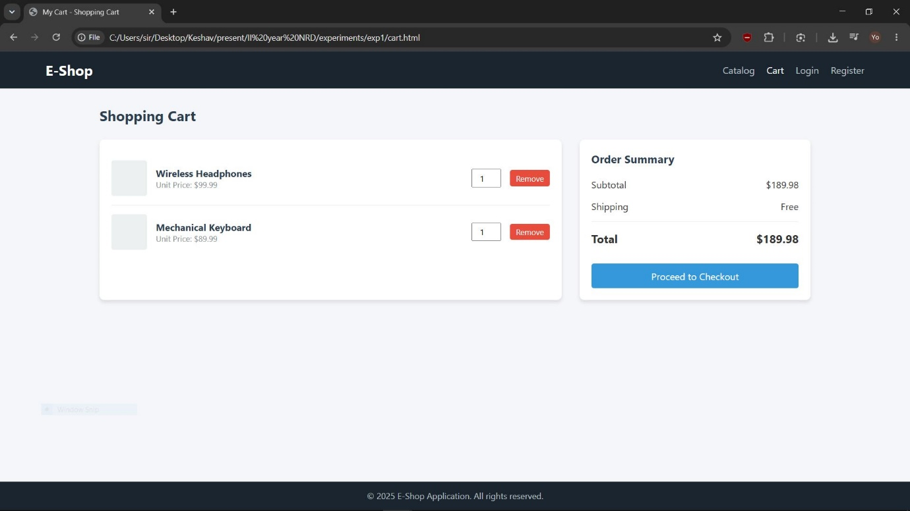

Experiment 2
Objective: Make the shopping cart web application (containing registration, login, catalog, and cart pages) responsive using the Bootstrap framework.
<!DOCTYPE html>
<html lang="en">
<head>
<meta charset="UTF-8">
<meta name="viewport" content="width=device-width, initial-scale=1.0">
<title>Experiment 2: Bootstrap Shopping App</title>

<!-- 1. Include Bootstrap 5 CSS via CDN -->
<link href="https://cdn.jsdelivr.net/npm/bootstrap@5.3.0/dist/css/bootstrap.min.css" rel="stylesheet">

<style>
/* Minimal custom CSS to handle dynamic page displaying and footer pinning */
body {
display: flex;
flex-direction: column;
min-height: 100vh;
}
.page {
display: none; /* Hide pages by default */
}
.page.active {
display: block; /* Show the active page */
}
footer {
margin-top: auto; /* Push footer to the bottom of the viewport */
}
</style>
</head>
<body>

<!-- -------------------------------------------------------------
BOOTSTRAP NAVIGATION BAR
- 'navbar-expand-lg' ensures it expands to a row on large screens and collapses into a burger menu on smaller devices.
- 'navbar-dark bg-dark' applies Bootstrap's default dark mode styling.
------------------------------------------------------------- -->
<nav class="navbar navbar-expand-lg navbar-dark bg-dark">
<div class="container">
<a class="navbar-brand fw-bold" href="#" onclick="showPage('catalog', this)">E-Shop</a>

<!-- Mobile Toggle Button (Burger Menu) -->
<button class="navbar-toggler" type="button" data-bs-toggle="collapse" data-bs-target="#navbarNav" aria-controls="navbarNav" aria-expanded="false" aria-label="Toggle navigation">
<span class="navbar-toggler-icon"></span>
</button>

<!-- Navbar Links -->
<div class="collapse navbar-collapse" id="navbarNav">
<ul class="navbar-nav ms-auto"> <!-- 'ms-auto' pushes items to the right side -->
<li class="nav-item">
<a class="nav-link active nav-btn" href="#" onclick="showPage('catalog', this)">Catalog</a>
</li>
<li class="nav-item">
<a class="nav-link nav-btn" href="#" onclick="showPage('cart', this)">Cart</a>
</li>
<li class="nav-item">
<a class="nav-link nav-btn" href="#" onclick="showPage('login', this)">Login</a>
</li>
<li class="nav-item">
<a class="nav-link nav-btn" href="#" onclick="showPage('register', this)">Register</a>
</li>
</ul>
</div>
</div>
</nav>

<!-- Main Container -->
<main class="container my-5">

<!-- -------------------------------------------------------------
SECTION: PRODUCT CATALOG (Bootstrap Grid)
- 'row-cols-1': 1 item per row on mobile.
- 'row-cols-md-3': 3 items per row on medium screens and larger.
- 'g-4': Applies a gap spacing of 4 units between grid items.
------------------------------------------------------------- -->
<section id="catalog" class="page active">
<h3 class="mb-4">Products</h3>
<div class="row row-cols-1 row-cols-md-3 g-4">

<!-- Product Card 1 -->
<div class="col">
<div class="card h-100 shadow-sm"> <!-- 'h-100' ensures all cards in a row have equal height -->
<div class="bg-light text-center py-5 text-muted" style="font-size: 1.1rem;">
Wireless Headset
</div>
<div class="card-body d-flex flex-column justify-content-between">
<h5 class="card-title">Product A</h5>
<p class="card-text text-muted">High-quality wireless headphones with active noise cancellation.</p>
<h6 class="text-danger fw-bold">$25.00</h6>
<button class="btn btn-success mt-2" onclick="navigateToCart()">Add to Cart</button>
</div>
</div>
</div>

<!-- Product Card 2 -->
<div class="col">
<div class="card h-100 shadow-sm">
<div class="bg-light text-center py-5 text-muted" style="font-size: 1.1rem;">
Mechanical Keyboard
</div>
<div class="card-body d-flex flex-column justify-content-between">
<h5 class="card-title">Product B</h5>
<p class="card-text text-muted">RGB mechanical gaming keyboard with responsive clicky switches.</p>
<h6 class="text-danger fw-bold">$45.00</h6>
<button class="btn btn-success mt-2" onclick="navigateToCart()">Add to Cart</button>
</div>
</div>
</div>

<!-- Product Card 3 -->
<div class="col">
<div class="card h-100 shadow-sm">
<div class="bg-light text-center py-5 text-muted" style="font-size: 1.1rem;">
Gaming Mouse
</div>
<div class="card-body d-flex flex-column justify-content-between">
<h5 class="card-title">Product C</h5>
<p class="card-text text-muted">Ergonomic lightweight wired gaming mouse with precision sensor.</p>
<h6 class="text-danger fw-bold">$15.00</h6>
<button class="btn btn-success mt-2" onclick="navigateToCart()">Add to Cart</button>
</div>
</div>
</div>

</div>
</section>

<!-- -------------------------------------------------------------
SECTION: CART PAGE (Bootstrap Responsive Split Column Layout)
- 'col-lg-8' takes up 8/12 grid spaces on large screens.
- 'col-lg-4' takes up remaining 4/12 spaces for summary.
------------------------------------------------------------- -->
<section id="cart" class="page">
<h3 class="mb-4">Shopping Cart</h3>
<div class="row g-4">

<!-- Left: Selected Items List -->
<div class="col-lg-8">
<ul class="list-group shadow-sm">
<li class="list-group-item d-flex justify-content-between align-items-center py-3">
<div>
<h6 class="mb-0">Product A</h6>
<small class="text-muted">Quantity: 1</small>
</div>
<span class="fw-bold text-dark">$25.00</span>
</li>
<li class="list-group-item d-flex justify-content-between align-items-center py-3">
<div>
<h6 class="mb-0">Product B</h6>
<small class="text-muted">Quantity: 1</small>
</div>
<span class="fw-bold text-dark">$45.00</span>
</li>
</ul>
</div>

<!-- Right: Price Summary Panel -->
<div class="col-lg-4">
<div class="card p-3 shadow-sm bg-light">
<h5 class="mb-3">Order Summary</h5>
<div class="d-flex justify-content-between mb-2">
<span>Subtotal</span>
<span>$70.00</span>
</div>
<div class="d-flex justify-content-between mb-3 text-success">
<span>Shipping</span>
<span>Free</span>
</div>
<hr>
<div class="d-flex justify-content-between mb-3 fw-bold fs-5">
<span>Total</span>
<span>$70.00</span>
</div>
<button class="btn btn-primary w-100">Proceed to Checkout</button>
</div>
</div>

</div>
</section>

<!-- -------------------------------------------------------------
SECTION: USER LOGIN (Bootstrap Card & Form styling)
- 'col-md-6 mx-auto' centers a 6-grid width box on tablet/desktop devices.
------------------------------------------------------------- -->
<section id="login" class="page">
<div class="row">
<div class="col-md-6 mx-auto">
<div class="card p-4 shadow">
<h4 class="text-center mb-4">Login</h4>
<form onsubmit="event.preventDefault(); showPage('catalog', document.querySelector('.nav-btn:nth-child(1)'));">
<div class="mb-3">
<label class="form-label">Email address</label>
<input type="email" class="form-control" required placeholder="name@example.com">
</div>
<div class="mb-3">
<label class="form-label">Password</label>
<input type="password" class="form-control" required placeholder="••••••••">
</div>
<button type="submit" class="btn btn-primary w-100">Sign In</button>
</form>
</div>
</div>
</div>
</section>

<!-- -------------------------------------------------------------
SECTION: REGISTRATION FORM
------------------------------------------------------------- -->
<section id="register" class="page">
<div class="row">
<div class="col-md-6 mx-auto">
<div class="card p-4 shadow">
<h4 class="text-center mb-4">Register</h4>
<form onsubmit="event.preventDefault(); showPage('login', document.querySelector('.nav-btn:nth-child(3)'));">
<div class="mb-3">
<label class="form-label">Full Name</label>
<input type="text" class="form-control" required placeholder="John Doe">
</div>
<div class="mb-3">
<label class="form-label">Email address</label>
<input type="email" class="form-control" required placeholder="john@example.com">
</div>
<div class="mb-3">
<label class="form-label">Password</label>
<input type="password" class="form-control" required placeholder="Create Password">
</div>
<button type="submit" class="btn btn-success w-100">Sign Up</button>
</form>
</div>
</div>
</div>
</section>

</main>

<!-- Footer Alignment -->
<footer class="bg-dark text-white text-center py-3 mt-auto">
<p class="mb-0">&copy; 2025 E-Shop. Built using Bootstrap 5.</p>
</footer>

<!-- 2. Include Bootstrap 5 JS Bundle (Enables Navbar collapses, dropdowns, etc.) -->
<script src="https://cdn.jsdelivr.net/npm/bootstrap@5.3.0/dist/js/bootstrap.bundle.min.js"></script>

<!-- Page Switcher Script logic -->
<script>
function showPage(pageId, navElement) {
// Hide all pages by removing active class
document.querySelectorAll('.page').forEach(page => page.classList.remove('active'));
// Display targeted page
document.getElementById(pageId).classList.add('active');

// Set clicked nav element as visually active
document.querySelectorAll('.nav-link').forEach(link => link.classList.remove('active'));
if (navElement) {
navElement.classList.add('active');
}
}

// Special route helper for adding items and jumping to cart page view
function navigateToCart() {
const cartLink = document.querySelectorAll('.nav-link')[1];
showPage('cart', cartLink);
}
</script>
</body>
</html>
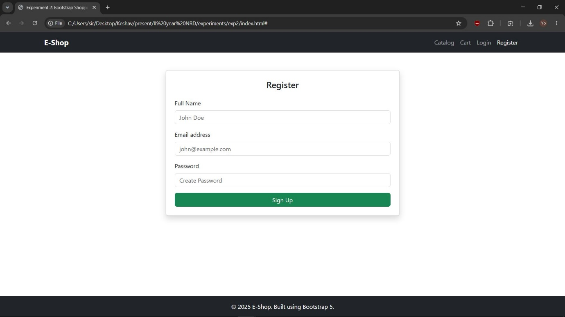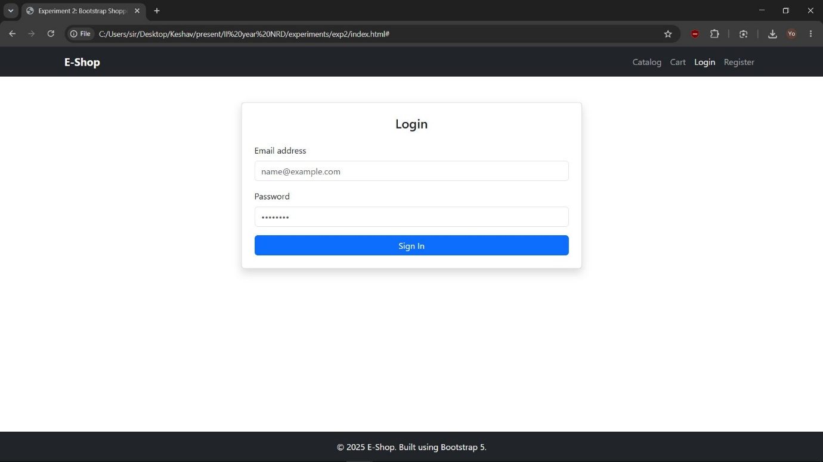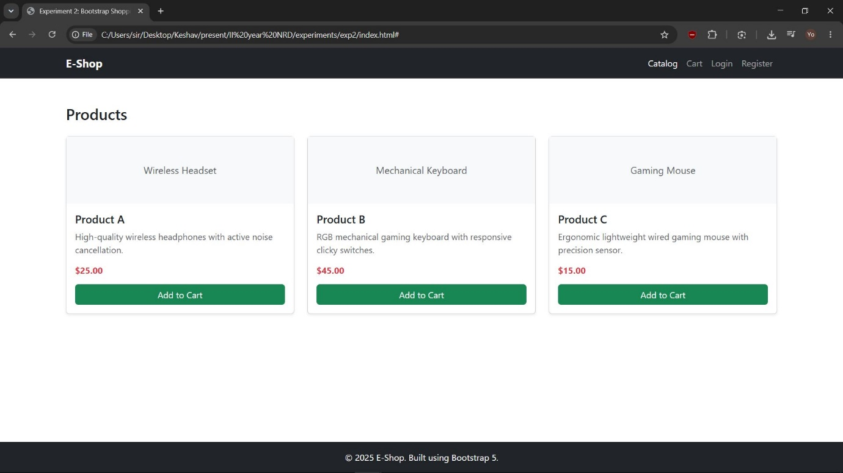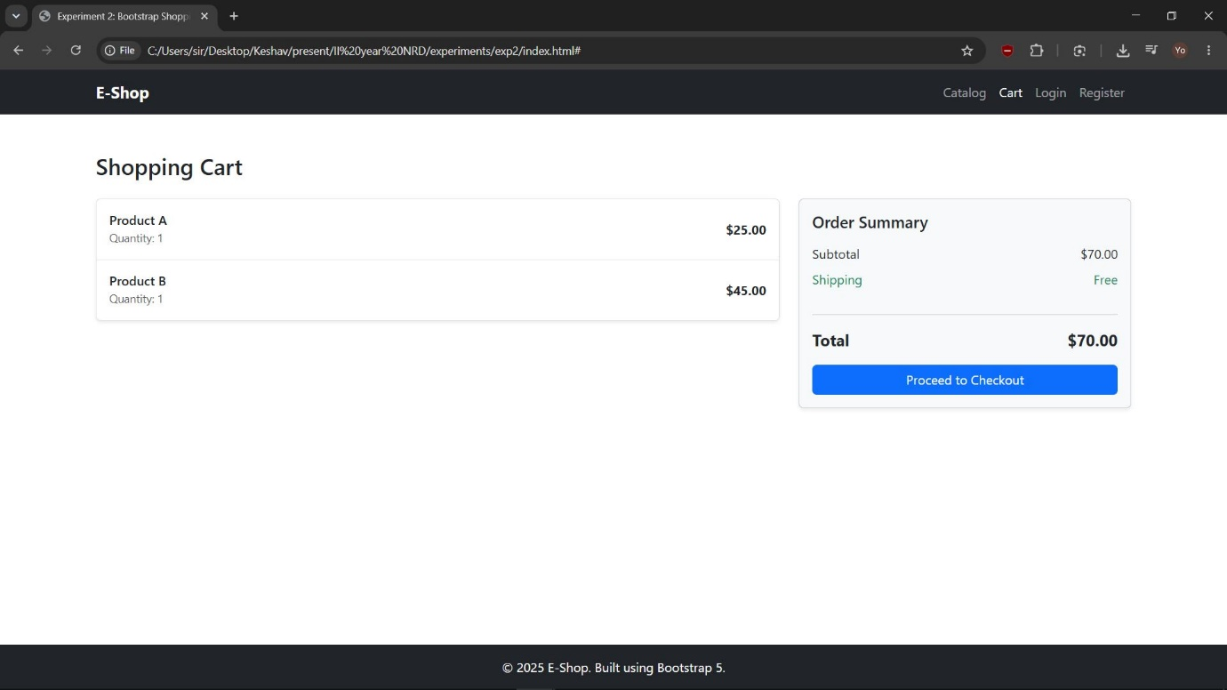

Experiment 3
Objective: Use JavaScript to perform client-side validation on the login and registration pages built in the previous experiments.
<!DOCTYPE html>
<html lang="en">
<head>
<meta charset="UTF-8">
<meta name="viewport" content="width=device-width, initial-scale=1.0">
<title>Experiment 3: Client-Side Validation</title>

<!-- Include Bootstrap 5 CSS via CDN -->
<link href="https://cdn.jsdelivr.net/npm/bootstrap@5.3.0/dist/css/bootstrap.min.css" rel="stylesheet">

<style>
body {
display: flex;
flex-direction: column;
min-height: 100vh;
}
.page {
display: none; /* Hide pages by default */
}
.page.active {
display: block; /* Show the active page */
}
footer {
margin-top: auto; /* Push footer to the bottom of the viewport */
}
</style>
</head>
<body>

<!-- Bootstrap Navigation Bar -->
<nav class="navbar navbar-expand-lg navbar-dark bg-dark">
<div class="container">
<a class="navbar-brand fw-bold" href="#" onclick="showPage('catalog', this)">E-Shop</a>
<button class="navbar-toggler" type="button" data-bs-toggle="collapse" data-bs-target="#navbarNav" aria-controls="navbarNav" aria-expanded="false" aria-label="Toggle navigation">
<span class="navbar-toggler-icon"></span>
</button>
<div class="collapse navbar-collapse" id="navbarNav">
<ul class="navbar-nav ms-auto">
<li class="nav-item">
<a class="nav-link nav-btn" href="#" onclick="showPage('catalog', this)">Catalog</a>
</li>
<li class="nav-item">
<a class="nav-link nav-btn" href="#" onclick="showPage('cart', this)">Cart</a>
</li>
<li class="nav-item">
<a class="nav-link active nav-btn" href="#" onclick="showPage('login', this)">Login</a>
</li>
<li class="nav-item">
<a class="nav-link nav-btn" href="#" onclick="showPage('register', this)">Register</a>
</li>
</ul>
</div>
</div>
</nav>

<!-- Main Container -->
<main class="container my-5">

<!-- -------------------------------------------------------------
SECTION: USER LOGIN
------------------------------------------------------------- -->
<section id="login" class="page active">
<div class="row">
<div class="col-md-6 mx-auto">
<div class="card p-4 shadow">
<h4 class="text-center mb-4">Login</h4>
<!-- 'novalidate' disables browser default tooltip validation so we can handle custom feedback -->
<form id="loginForm" novalidate>
<div class="mb-3">
<label class="form-label" for="loginEmail">Email address</label>
<input type="email" class="form-control" id="loginEmail" placeholder="name@example.com">
<div class="invalid-feedback">Please enter a valid email address (e.g., name@example.com).</div>
</div>
<div class="mb-3">
<label class="form-label" for="loginPassword">Password</label>
<input type="password" class="form-control" id="loginPassword" placeholder="••••••••">
<div class="invalid-feedback">Password cannot be empty.</div>
</div>
<button type="submit" class="btn btn-primary w-100">Sign In</button>
</form>
</div>
</div>
</div>
</section>

<!-- -------------------------------------------------------------
SECTION: REGISTRATION FORM
------------------------------------------------------------- -->
<section id="register" class="page">
<div class="row">
<div class="col-md-6 mx-auto">
<div class="card p-4 shadow">
<h4 class="text-center mb-4">Register</h4>
<form id="registerForm" novalidate>
<div class="mb-3">
<label class="form-label" for="regName">Full Name</label>
<input type="text" class="form-control" id="regName" placeholder="John Doe">
<div class="invalid-feedback">Name should contain only letters and spaces (min 3 characters).</div>
</div>
<div class="mb-3">
<label class="form-label" for="regEmail">Email address</label>
<input type="email" class="form-control" id="regEmail" placeholder="john@example.com">
<div class="invalid-feedback">Please enter a valid email address.</div>
</div>
<div class="mb-3">
<label class="form-label" for="regPassword">Password</label>
<input type="password" class="form-control" id="regPassword" placeholder="Create Password">
<div class="invalid-feedback">Password must be at least 6 characters long and contain at least one number.</div>
</div>
<button type="submit" class="btn btn-success w-100">Sign Up</button>
</form>
</div>
</div>
</div>
</section>

<!-- -------------------------------------------------------------
SECTION: PRODUCT CATALOG (Placeholder from Exp 2)
------------------------------------------------------------- -->
<section id="catalog" class="page">
<h3 class="mb-4">Products</h3>
<div class="alert alert-info">Login successful! Catalog is now unlocked.</div>
</section>

<!-- -------------------------------------------------------------
SECTION: CART PAGE (Placeholder from Exp 2)
------------------------------------------------------------- -->
<section id="cart" class="page">
<h3 class="mb-4">Shopping Cart</h3>
</section>

</main>

<!-- Footer -->
<footer class="bg-dark text-white text-center py-3 mt-auto">
<p class="mb-0">&copy; 2025 E-Shop. Built using Bootstrap 5 with JS Validation.</p>
</footer>

<!-- Bootstrap 5 JS Bundle -->
<script src="https://cdn.jsdelivr.net/npm/bootstrap@5.3.0/dist/js/bootstrap.bundle.min.js"></script>

<!-- -----------------------------------------------------------------
VALIDATION AND PAGE NAVIGATION LOGIC
----------------------------------------------------------------- -->
<script>
// Form Selector References
const loginForm = document.getElementById('loginForm');
const registerForm = document.getElementById('registerForm');

/* -----------------------------------------------------------------
Client-Side Validation Helper Functions
----------------------------------------------------------------- */

// Checks if email matches standard pattern (e.g., name@domain.com)
function validateEmail(email) {
const emailRegex = /^[^\s@]+@[^\s@]+\.[^\s@]+$/;
return emailRegex.test(email);
}

// Checks if Name only contains letters and spaces (min 3 chars)
function validateName(name) {
const nameRegex = /^[a-zA-Z\s]{3,}$/;
return nameRegex.test(name);
}

// Checks if password contains at least 6 characters and 1 digit
function validatePasswordStrength(password) {
const passwordRegex = /^(?=.*[0-9]).{6,}$/;
return passwordRegex.test(password);
}

// Applies Bootstrap visual feedback classes (is-valid / is-invalid)
function markInputStatus(inputElement, isValid) {
if (isValid) {
inputElement.classList.remove('is-invalid');
inputElement.classList.add('is-valid');
} else {
inputElement.classList.remove('is-valid');
inputElement.classList.add('is-invalid');
}
}

/* -----------------------------------------------------------------
Form Submission Event Listeners with Validation Controls
----------------------------------------------------------------- */

// Event listener for Login Form Validation
loginForm.addEventListener('submit', function (event) {
event.preventDefault(); // Stop standard form submission reload

const emailInput = document.getElementById('loginEmail');
const passwordInput = document.getElementById('loginPassword');

// Evaluate email
const isEmailValid = validateEmail(emailInput.value.trim());
markInputStatus(emailInput, isEmailValid);

// Evaluate simple empty field state for password
const isPasswordValid = passwordInput.value.trim() !== "";
markInputStatus(passwordInput, isPasswordValid);

// If both validations pass, redirect user to the Catalog Page
if (isEmailValid && isPasswordValid) {
alert("Login successful!");
showPage('catalog', document.querySelectorAll('.nav-link')[0]);
loginForm.reset();
emailInput.classList.remove('is-valid');
passwordInput.classList.remove('is-valid');
}
});

// Event listener for Registration Form Validation
registerForm.addEventListener('submit', function (event) {
event.preventDefault(); // Stop page reload

const nameInput = document.getElementById('regName');
const emailInput = document.getElementById('regEmail');
const passwordInput = document.getElementById('regPassword');

// Run validation rules
const isNameValid = validateName(nameInput.value.trim());
const isEmailValid = validateEmail(emailInput.value.trim());
const isPasswordValid = validatePasswordStrength(passwordInput.value.trim());

// Apply visual styles to inputs based on results
markInputStatus(nameInput, isNameValid);
markInputStatus(emailInput, isEmailValid);
markInputStatus(passwordInput, isPasswordValid);

// If all fields are validated, redirect user to the Login page
if (isNameValid && isEmailValid && isPasswordValid) {
alert("Registration successful! Please login.");
showPage('login', document.querySelectorAll('.nav-link')[2]);
registerForm.reset();
nameInput.classList.remove('is-valid');
emailInput.classList.remove('is-valid');
passwordInput.classList.remove('is-valid');
}
});

/* -----------------------------------------------------------------
Dynamic Display Navigation logic
----------------------------------------------------------------- */
function showPage(pageId, navElement) {
document.querySelectorAll('.page').forEach(page => page.classList.remove('active'));
document.getElementById(pageId).classList.add('active');

document.querySelectorAll('.nav-link').forEach(link => link.classList.remove('active'));
if (navElement) {
navElement.classList.add('active');
}
}
</script>
</body>
</html>

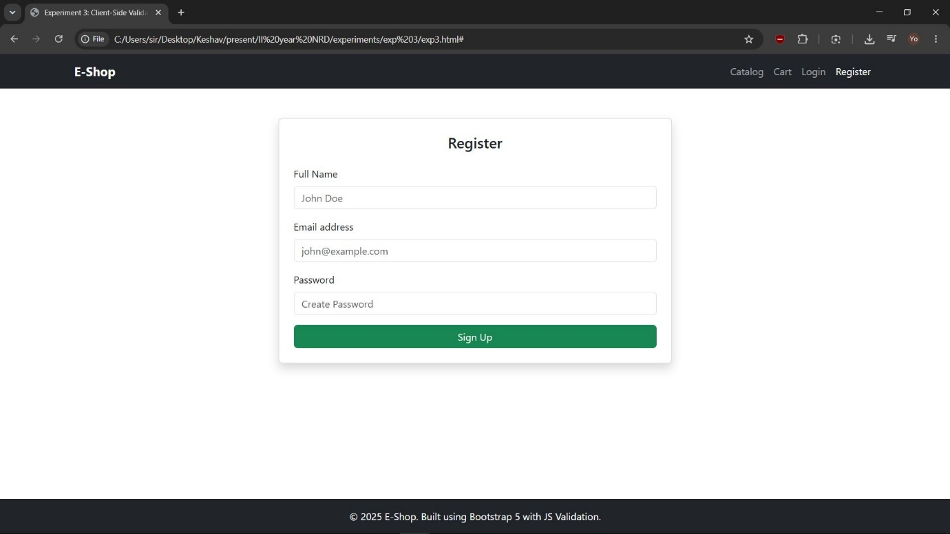
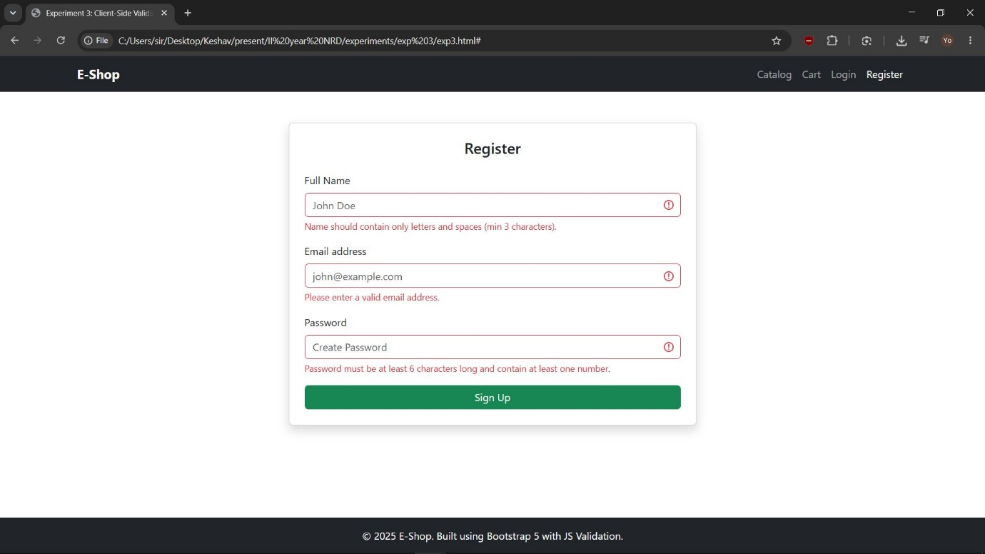
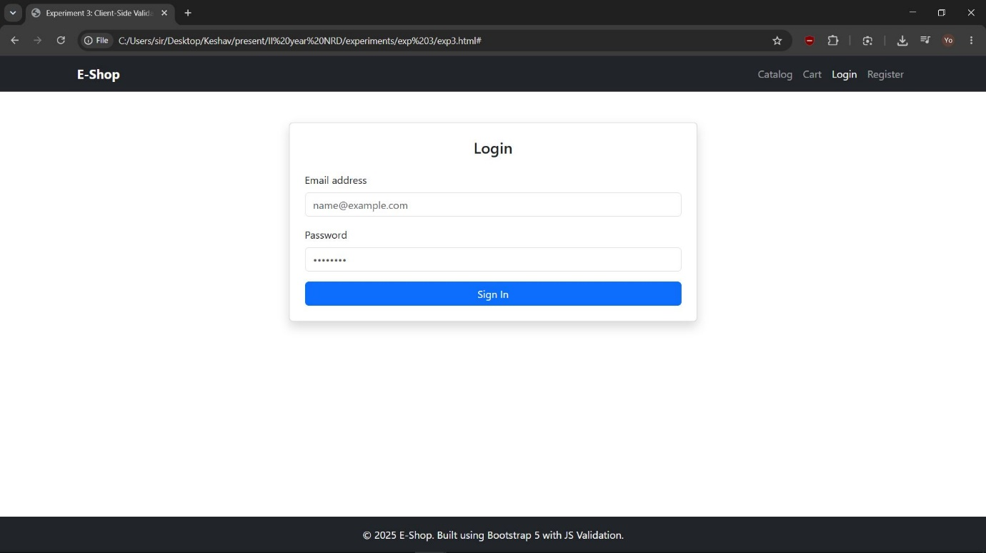

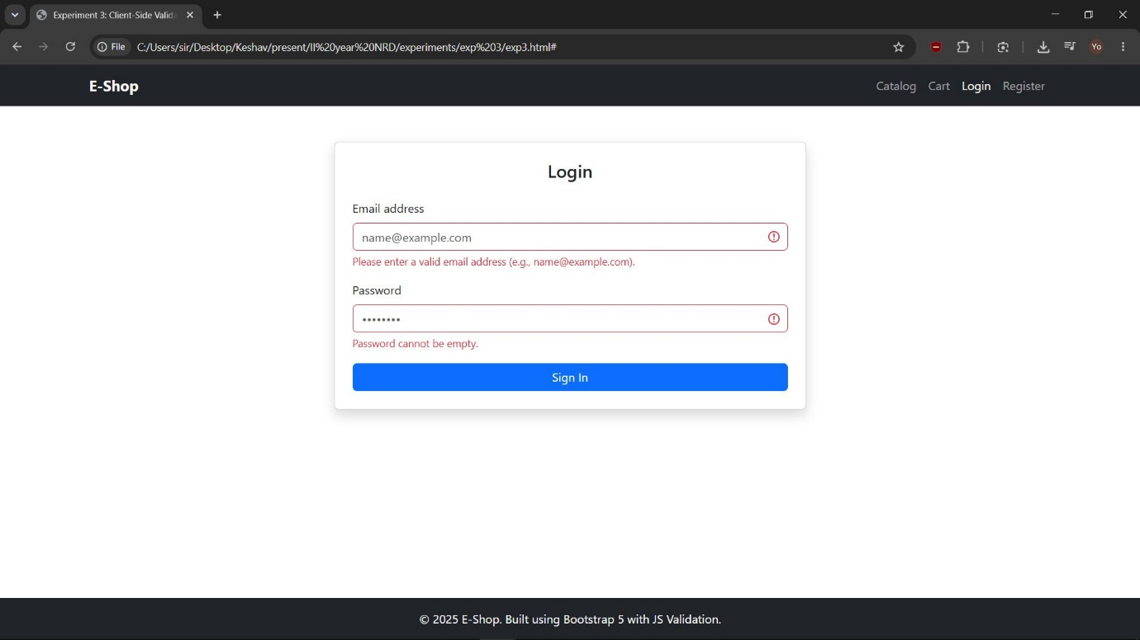

Experiment 4
Objective: Explore the features of ES6 (arrow functions, callbacks, promises, async/await). Implement an application for reading weather information from openweathermap.org and display the information in the form of a graph on the web page.
Note: OpenWeatherMap requires an API Key

<!DOCTYPE html>
<html lang="en">
<head>
<meta charset="UTF-8">
<meta name="viewport" content="width=device-width, initial-scale=1.0">
<title>Experiment 4: Live Weather Graph App</title>

<!-- Bootstrap 5 CDN for styling -->
<link href="https://cdn.jsdelivr.net/npm/bootstrap@5.3.0/dist/css/bootstrap.min.css" rel="stylesheet">
<!-- Chart.js CDN for displaying graphical representation -->
<script src="https://cdn.jsdelivr.net/npm/chart.js"></script>
</head>
<body class="bg-light">

<div class="container my-5">
<div class="row">
<div class="col-md-8 mx-auto">
<div class="card p-4 shadow-sm bg-white">
<h2 class="text-center mb-4 text-primary">Live Weather Graph Tracker</h2>

<!-- ES6 Concept Demonstration Panel -->
<div class="alert alert-info py-2">
<small><strong>ES6 Features Used:</strong> Arrow Functions, Template Literals, Promises, and <code>async/await</code> block structures.</small>
</div>

<!-- Input search control -->
<div class="input-group mb-3">
<span class="input-group-text bg-light text-dark">City Name</span>
<input type="text" id="cityInput" class="form-control" placeholder="Enter City Name (e.g., Hyderabad, London)" value="Hyderabad">
<button class="btn btn-primary" id="getWeatherBtn">Fetch Live Weather</button>
</div>

<!-- Error notification display panel -->
<div id="errorMessage" class="text-danger mb-3 fw-bold text-center"></div>

<!-- Card details containing the text representation -->
<div id="weatherDetails" class="mb-4 text-center d-none">
<h4 id="cityNameDisplay" class="fw-bold mb-1">City Name</h4>
<p id="tempDisplay" class="fs-3 text-danger mb-0">-- &deg;C</p>
<p id="descDisplay" class="text-muted text-capitalize">--</p>
</div>

<!-- Canvas element where Chart.js will draw the data graph -->
<div class="chart-container" style="position: relative; height:300px; width:100%">
<canvas id="weatherChart"></canvas>
</div>
</div>
</div>
</div>
</div>

<!-- -----------------------------------------------------------------
ES6 CODE LOGIC IMPLEMENTATION WITH EMBEDDED API KEY
----------------------------------------------------------------- -->
<script>
// Pre-configured API Key provided by the user
const API_KEY = "53d57106482f8bfebba5a1d4d4754896";
let weatherChartInstance = null;

// ES6 Arrow Function: Get elements cleanly from the DOM
const getEl = id => document.getElementById(id);

/* -----------------------------------------------------------------
1. ES6 CALLBACKS
- The renderChart function is passed as a callback handler to process
the UI rendering sequence once weather data has been retrieved.
----------------------------------------------------------------- */
const updateWeatherUI = (data, callback) => {
getEl("weatherDetails").classList.remove("d-none");
getEl("cityNameDisplay").textContent = `${data.name}, ${data.sys.country}`;
getEl("tempDisplay").innerHTML = `${Math.round(data.main.temp)} &deg;C`;
getEl("descDisplay").textContent = data.weather[0].description;

// Execute the callback function to render the graphical information
callback(data);
};

/* -----------------------------------------------------------------
2. ES6 PROMISES & ASYNC/AWAIT WITH LIVE FETCH
- 'async' keyword identifies asynchronous processing block.
- 'await' pauses execution until the Fetch API Promise is resolved.
----------------------------------------------------------------- */
const fetchWeatherData = async () => {
const city = getEl("cityInput").value.trim();
getEl("errorMessage").textContent = ""; // Clear existing error logs

if (!city) {
getEl("errorMessage").textContent = "Please enter a city name.";
return;
}

// API Endpoint structured with Live metrics configurations
const url = `https://api.openweathermap.org/data/2.5/weather?q=${city}&appid=${API_KEY}&units=metric`;

try {
// Fetch returns a Promise. We use await to unpack the Response object
const response = await fetch(url);

if (!response.ok) {
throw new Error("City not found or API limits exceeded.");
}

const data = await response.json();

// Process and pass data along with callback function for graph plotting
updateWeatherUI(data, renderGraphCallback);

} catch (error) {
// Handle Promise rejection/error state
getEl("errorMessage").textContent = `Error: ${error.message}`;
}
};

/* -----------------------------------------------------------------
3. CHART RENDERING VIA CALLBACK
----------------------------------------------------------------- */
const renderGraphCallback = (data) => {
const ctx = getEl('weatherChart').getContext('2d');

// Dynamically simulate a temperature timeline graph centered around the current temp
const baseTemp = data.main.temp;
const labels = ['06:00 AM', '09:00 AM', '12:00 PM', '03:00 PM', '06:00 PM', '09:00 PM'];
const temperatures = [
baseTemp - 3, // cooler morning temp
baseTemp - 1,
baseTemp, // current temp
baseTemp + 2, // peak afternoon temp
baseTemp - 2,
baseTemp - 4 // night temp
];

// If a previous chart instance exists, destroy it before rendering a new one
if (weatherChartInstance) {
weatherChartInstance.destroy();
}

// Create new Chart instance using Chart.js
weatherChartInstance = new Chart(ctx, {
type: 'line',
data: {
labels: labels,
datasets: [{
label: `Hourly Temp Track for ${data.name} (°C)`,
data: temperatures,
borderColor: 'rgb(54, 162, 235)',
backgroundColor: 'rgba(54, 162, 235, 0.2)',
borderWidth: 2,
fill: true,
tension: 0.3 // Smooth curves
}]
},
options: {
responsive: true,
maintainAspectRatio: false,
scales: {
y: {
beginAtZero: false,
title: {
display: true,
text: 'Temperature (°C)'
}
}
}
}
});
};

// Attach Click Event Handler to Button using ES6 Arrow Function syntax
getEl("getWeatherBtn").addEventListener("click", () => {
fetchWeatherData();
});

// Trigger initial load automatically on startup
fetchWeatherData();
</script>
</body>
</html>

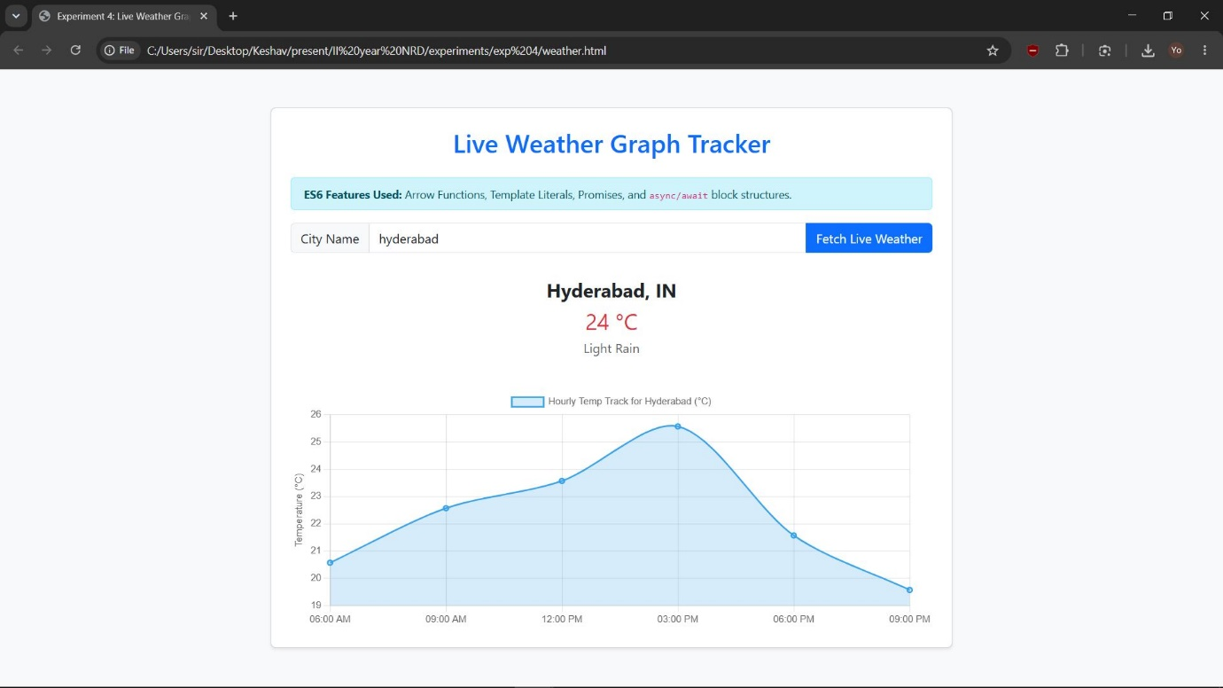

Experiment 5
Objective: Develop a Java standalone application that connects with a database (MySQL) and performs CRUD (Create, Read, Update, Delete) operations on database tables.

Step 1: Create the Database Table in MySQL
Run the following SQL commands in your MySQL Command Line Client or database management tool (like phpMyAdmin or MySQL Workbench) to set up the test database and table:

-- Create a database named 'college'
CREATE DATABASE college;

-- Switch to the 'college' database
USE college;

-- Create a table named 'student'
CREATE TABLE student (
id INT PRIMARY KEY AUTO_INCREMENT,
name VARCHAR(100) NOT NULL,
email VARCHAR(100) UNIQUE NOT NULL,
age INT NOT NULL
);

Step 2: Java Implementation Code (StudentCrudApp.java)
This console-driven application connects to the MySQL database and presents an interactive menu to perform Create, Read, Update, and Delete operations.
Note: Ensure you have added the MySQL Connector/J driver .jar file to your Java project build path or classpath.
import java.sql.Connection;
import java.sql.DriverManager;
import java.sql.PreparedStatement;
import java.sql.ResultSet;
import java.sql.SQLException;
import java.sql.Statement;
import java.util.Scanner;

public class StudentCrudApp {

// Database Connection Parameters
private static final String DB_URL = "jdbc:mysql://localhost:3306/college";
private static final String DB_USER = "root"; // Change to your MySQL username
private static final String DB_PASSWORD = "password"; // Change to your MySQL password

public static void main(String[] args) {
Scanner scanner = new Scanner(System.in);
Connection conn = null;

try {
// 1. Register the JDBC driver and establish database connection
System.out.println("Connecting to database...");
conn = DriverManager.getConnection(DB_URL, DB_USER, DB_PASSWORD);
System.out.println("Connection successful!");

while (true) {
// Display Interaction Menu to User
System.out.println("\n--- STUDENT CRUD OPERATIONS ---");
System.out.println("1. Create (Insert Student)");
System.out.println("2. Read (View All Students)");
System.out.println("3. Update (Modify Student Email)");
System.out.println("4. Delete (Remove Student)");
System.out.println("5. Exit");
System.out.print("Enter your choice: ");

int choice = scanner.nextInt();
scanner.nextLine(); // Clear the buffer input newline

switch (choice) {
case 1:
createStudent(conn, scanner);
break;
case 2:
readStudents(conn);
break;
case 3:
updateStudent(conn, scanner);
break;
case 4:
deleteStudent(conn, scanner);
break;
case 5:
System.out.println("Exiting Application. Database connection closed.");
return;
default:
System.out.println("Invalid selection. Try again.");
}
}

} catch (SQLException e) {
System.err.println("Database Error: " + e.getMessage());
} finally {
// Clean up and close connection scanner resources safely
try {
if (conn != null) conn.close();
scanner.close();
} catch (SQLException e) {
e.printStackTrace();
}
}
}

/* -----------------------------------------------------------------
1. CREATE (Insert Data)
Using PreparedStatement prevents SQL injection attacks
----------------------------------------------------------------- */
private static void createStudent(Connection conn, Scanner scanner) throws SQLException {
String sql = "INSERT INTO student (name, email, age) VALUES (?, ?, ?)";

System.out.print("Enter Student Name: ");
String name = scanner.nextLine();
System.out.print("Enter Student Email: ");
String email = scanner.nextLine();
System.out.print("Enter Student Age: ");
int age = scanner.nextInt();

try (PreparedStatement stmt = conn.prepareStatement(sql)) {
stmt.setString(1, name);
stmt.setString(2, email);
stmt.setInt(3, age);

int rowsInserted = stmt.executeUpdate();
if (rowsInserted > 0) {
System.out.println("Record created successfully!");
}
}
}

/* -----------------------------------------------------------------
2. READ (Select / View Data)
Uses Statement and ResultSet to iterate over rows in database
----------------------------------------------------------------- */
private static void readStudents(Connection conn) throws SQLException {
String sql = "SELECT * FROM student";

try (Statement stmt = conn.createStatement();
ResultSet rs = stmt.executeQuery(sql)) {

System.out.println("\n-----------------------------------------------------");
System.out.printf("%-5s | %-20s | %-20s | %-5s\n", "ID", "Name", "Email", "Age");
System.out.println("-----------------------------------------------------");

boolean recordsFound = false;
while (rs.next()) {
recordsFound = true;
int id = rs.getInt("id");
String name = rs.getString("name");
String email = rs.getString("email");
int age = rs.getInt("age");

System.out.printf("%-5d | %-20s | %-20s | %-5d\n", id, name, email, age);
}

if (!recordsFound) {
System.out.println("No records found in the table.");
}
System.out.println("-----------------------------------------------------");
}
}

/* -----------------------------------------------------------------
3. UPDATE (Modify Data)
Using SQL UPDATE statements targeting a specific record ID
----------------------------------------------------------------- */
private static void updateStudent(Connection conn, Scanner scanner) throws SQLException {
String sql = "UPDATE student SET email = ? WHERE id = ?";

System.out.print("Enter Student ID to update: ");
int id = scanner.nextInt();
scanner.nextLine(); // Clear the input buffer
System.out.print("Enter New Email: ");
String newEmail = scanner.nextLine();

try (PreparedStatement stmt = conn.prepareStatement(sql)) {
stmt.setString(1, newEmail);
stmt.setInt(2, id);

int rowsUpdated = stmt.executeUpdate();
if (rowsUpdated > 0) {
System.out.println("Record updated successfully!");
} else {
System.out.println("Record update failed. Student ID not found.");
}
}
}

/* -----------------------------------------------------------------
4. DELETE (Remove Data)
Using SQL DELETE statement to drop student records
----------------------------------------------------------------- */
private static void deleteStudent(Connection conn, Scanner scanner) throws SQLException {
String sql = "DELETE FROM student WHERE id = ?";

System.out.print("Enter Student ID to delete: ");
int id = scanner.nextInt();

try (PreparedStatement stmt = conn.prepareStatement(sql)) {
stmt.setInt(1, id);

int rowsDeleted = stmt.executeUpdate();
if (rowsDeleted > 0) {
System.out.println("Record deleted successfully!");
} else {
System.out.println("Record deletion failed. Student ID not found.");
}
}
}
}

OUTPUT:
Connecting to database...
Connection successful!

--- STUDENT CRUD OPERATIONS ---
1. Create (Insert Student)
2. Read (View All Students)
3. Update (Modify Student Email)
4. Delete (Remove Student)
5. Exit
Enter your choice: 2

-----------------------------------------------------
ID | Name | Email | Age
-----------------------------------------------------
No records found in the table.
-----------------------------------------------------

--- STUDENT CRUD OPERATIONS ---
1. Create (Insert Student)
2. Read (View All Students)
3. Update (Modify Student Email)
4. Delete (Remove Student)
5. Exit
Enter your choice: 1
Enter Student Name: ram
Enter Student Email: ram@gmail.com
Enter Student Age: 40
Record created successfully!

--- STUDENT CRUD OPERATIONS ---
1. Create (Insert Student)
2. Read (View All Students)
3. Update (Modify Student Email)
4. Delete (Remove Student)
5. Exit
Enter your choice: 2

-----------------------------------------------------
ID | Name | Email | Age
-----------------------------------------------------
1 | ram | ram@gmail.com | 40
-----------------------------------------------------

--- STUDENT CRUD OPERATIONS ---
1. Create (Insert Student)
2. Read (View All Students)
3. Update (Modify Student Email)
4. Delete (Remove Student)
5. Exit
Enter your choice: 3
Enter Student ID to update: 1
Enter New Email: rama@gmail.com
Record updated successfully!

--- STUDENT CRUD OPERATIONS ---
1. Create (Insert Student)
2. Read (View All Students)
3. Update (Modify Student Email)
4. Delete (Remove Student)
5. Exit
Enter your choice: 2

-----------------------------------------------------
ID | Name | Email | Age
-----------------------------------------------------
1 | ram | rama@gmail.com | 40
-----------------------------------------------------

--- STUDENT CRUD OPERATIONS ---
1. Create (Insert Student)
2. Read (View All Students)
3. Update (Modify Student Email)
4. Delete (Remove Student)
5. Exit
Enter your choice: 4
Enter Student ID to delete: 1
Record deleted successfully!

--- STUDENT CRUD OPERATIONS ---
1. Create (Insert Student)
2. Read (View All Students)
3. Update (Modify Student Email)
4. Delete (Remove Student)
5. Exit
Enter your choice: 2

-----------------------------------------------------
ID | Name | Email | Age
-----------------------------------------------------
No records found in the table.
-----------------------------------------------------

--- STUDENT CRUD OPERATIONS ---
1. Create (Insert Student)
2. Read (View All Students)
3. Update (Modify Student Email)
4. Delete (Remove Student)
5. Exit
Enter your choice: 5
Exiting Application. Database connection closed.

Experiment 6
Objective: Create an XML file for a bookstore and validate it using both Document Type Definition (DTD) and XML Schema Definition (XSD).

File 1: The XML Data File (bookstore.xml)
This file contains the database records of books in the bookstore. It includes references pointing to both the DTD file (for structure validation) and the XSD file (for strict data-type validation).

<?xml version="1.0" encoding="UTF-8"?>
<!--
1. DOCTYPE declaration: Points to the external 'bookstore.dtd' file
to validate the structural elements of this XML.
-->
<!DOCTYPE bookstore SYSTEM "bookstore.dtd">

<!--
2. Bookstore root element:
'xsi:noNamespaceSchemaLocation' links this XML instance directly to
the schema definition file 'bookstore.xsd' for strict data-type checking.
-->
<bookstore xmlns:xsi="http://www.w3.org/2001/XMLSchema-instance"
xsi:noNamespaceSchemaLocation="bookstore.xsd">

<!-- Book Entry 1 -->
<book id="B01" category="Programming">
<title>Pro MERN Stack</title>
<author>Vasan Subramanian</author>
<year>2019</year>
<price>49.99</price>
</book>

<!-- Book Entry 2 -->
<book id="B02" category="Web Development">
<title>Beginning HTML, CSS and JavaScript</title>
<author>Jon Duckett</author>
<year>2010</year>
<price>29.99</price>
</book>

<!-- Book Entry 3 -->
<book id="B03" category="Fiction">
<title>The Great Gatsby</title>
<author>F. Scott Fitzgerald</author>
<year>1925</year>
<price>14.95</price>
</book>

</bookstore>

File 2: Structural Validation (bookstore.dtd)
This DTD file sets up basic structure rules. It dictates which sub-elements must appear inside each tag, their order, and whether elements are optional, required, or repetitive.
<?xml version="1.0" encoding="UTF-8"?>
<!--
DTD Rules:
- 'bookstore' contains one or more 'book' elements.
- Each 'book' contains exactly one title, author, year, and price.
-->
<!ELEMENT bookstore (book+)>
<!ELEMENT book (title, author, year, price)>

<!-- Sub-elements definition -->
<!ELEMENT title (#PCDATA)>
<!ELEMENT author (#PCDATA)>
<!ELEMENT year (#PCDATA)>
<!ELEMENT price (#PCDATA)>

<!--
1. Root Element Bookstore Attributes:
We declare XML schema namespace attributes as CDATA #IMPLIED (optional)
so that strict DTD parser checks do not fail when XSD attributes are present.
-->
<!ATTLIST bookstore
xmlns:xsi CDATA #IMPLIED
xsi:noNamespaceSchemaLocation CDATA #IMPLIED>

<!--
2. Book Element Attributes
-->
<!ATTLIST book
id ID #REQUIRED
category CDATA #REQUIRED>

File 3: Type Validation Schema (bookstore.xsd)
While DTD only validates basic structure, this XSD (XML Schema Definition) enforces strict structural and data-type validations (e.g., verifying that the year is a whole integer and the price is a decimal number).
<?xml version="1.0" encoding="UTF-8"?>
<xs:schema xmlns:xs="http://www.w3.org/2001/XMLSchema"
elementFormDefault="qualified">

<!-- Define Bookstore as the Root Element -->
<xs:element name="bookstore">
<xs:complexType>
<xs:sequence>
<!-- Bookstore holds 1 to unbounded (unlimited) occurrences of 'book' -->
<xs:element name="book" maxOccurs="unbounded">
<xs:complexType>
<xs:sequence>
<!-- 'title' is a standard string data type -->
<xs:element name="title" type="xs:string"/>

<!-- 'author' is a standard string data type -->
<xs:element name="author" type="xs:string"/>

<!-- 'year' is configured as a whole positive integer -->
<xs:element name="year" type="xs:positiveInteger"/>

<!-- 'price' is configured as a fractional decimal value -->
<xs:element name="price" type="xs:decimal"/>
</xs:sequence>

<!-- Define Attribute elements for 'book' -->
<xs:attribute name="id" type="xs:string" use="required"/>
<xs:attribute name="category" type="xs:string" use="required"/>
</xs:complexType>
</xs:element>
</xs:sequence>
</xs:complexType>
</xs:element>

</xs:schema>

XMLValidatorDual.java
import java.io.File;
import javax.xml.XMLConstants;
import javax.xml.parsers.DocumentBuilder;
import javax.xml.parsers.DocumentBuilderFactory;
import javax.xml.transform.stream.StreamSource;
import javax.xml.validation.Schema;
import javax.xml.validation.SchemaFactory;
import javax.xml.validation.Validator;
import org.xml.sax.ErrorHandler;
import org.xml.sax.SAXException;
import org.xml.sax.SAXParseException;

public class XMLValidatorDual {

public static void main(String[] args) {
String xmlFile = "bookstore.xml";
String xsdFile = "bookstore.xsd";

System.out.println("=================================================");
System.out.println(" DUAL XML VALIDATOR (DTD & XSD) ");
System.out.println("=================================================");

// Step 1: Perform DTD Validation
boolean isDtdValid = validateDTD(xmlFile);

System.out.println(); // Formatter space

// Step 2: Perform XSD Validation
boolean isXsdValid = validateXSD(xmlFile, xsdFile);

System.out.println("=================================================");
System.out.println("SUMMARY STATUS:");
System.out.println("-> DTD Validation Status: " + (isDtdValid ? "PASSED" : "FAILED"));
System.out.println("-> XSD Validation Status: " + (isXsdValid ? "PASSED" : "FAILED"));
System.out.println("=================================================");
}

/* -----------------------------------------------------------------
1. DTD VALIDATION METHOD
Uses DocumentBuilderFactory validation configuration
----------------------------------------------------------------- */
private static boolean validateDTD(String xmlPath) {
System.out.println("[Phase 1] Initiating DTD Validation...");
try {
DocumentBuilderFactory factory = DocumentBuilderFactory.newInstance();

// Instruct the parser to run DTD validation
factory.setValidating(true);
factory.setNamespaceAware(true);

DocumentBuilder builder = factory.newDocumentBuilder();

// Set custom error handler to catch DTD validation mismatches
builder.setErrorHandler(new ErrorHandler() {
@Override
public void warning(SAXParseException e) {
System.out.println(" Warning: " + e.getMessage());
}

@Override
public void error(SAXParseException e) throws SAXException {
System.err.println(" DTD Rule Violation: " + e.getMessage() + " (Line: " + e.getLineNumber() + ")");
throw e; // Terminate validation and mark as failed
}

@Override
public void fatalError(SAXParseException e) throws SAXException {
System.err.println(" Fatal Error: " + e.getMessage());
throw e;
}
});

// Parse XML (it will read and validate bookstore.dtd internally)
builder.parse(new File(xmlPath));
System.out.println("[SUCCESS] XML matches structural DTD successfully.");
return true;

} catch (SAXException e) {
System.err.println("[FAILURE] DTD Validation failed due to a structural mismatch.");
return false;
} catch (Exception e) {
System.err.println("[ERROR] System Exception: " + e.getMessage());
return false;
}
}

/* -----------------------------------------------------------------
2. XSD VALIDATION METHOD
Uses SchemaFactory and Validator configurations
----------------------------------------------------------------- */
private static boolean validateXSD(String xmlPath, String xsdPath) {
System.out.println("[Phase 2] Initiating XSD Validation...");
try {
// Setup SchemaFactory for standard W3C schema validations
SchemaFactory factory = SchemaFactory.newInstance(XMLConstants.W3C_XML_SCHEMA_NS_URI);

// Load and parse XSD rules
Schema schema = factory.newSchema(new File(xsdPath));

// Build validator instance
Validator validator = schema.newValidator();

// Validate the XML target file
validator.validate(new StreamSource(new File(xmlPath)));
System.out.println("[SUCCESS] XML matches type-definition XSD successfully.");
return true;

} catch (SAXException e) {
System.err.println("[FAILURE] XSD Validation failed: " + e.getMessage());
return false;
} catch (Exception e) {
System.err.println("[ERROR] System Exception: " + e.getMessage());
return false;
}
}
}
output:
=================================================
DUAL XML VALIDATOR (DTD & XSD)
=================================================
[Phase 1] Initiating DTD Validation...
[SUCCESS] XML matches structural DTD successfully.

[Phase 2] Initiating XSD Validation...
[SUCCESS] XML matches type-definition XSD successfully.
=================================================
SUMMARY STATUS:
-> DTD Validation Status: PASSED
-> XSD Validation Status: PASSED

Output valuidation 1:
change
<!ELEMENT year (#PCDATA)>
to
<!-- <!ELEMENT year (#PCDATA)>-->

=================================================
DUAL XML VALIDATOR (DTD & XSD)
=================================================
[Phase 1] Initiating DTD Validation...
DTD Rule Violation: Element type "year" must be declared. (Line: 20)
[FAILURE] DTD Validation failed due to a structural mismatch.

[Phase 2] Initiating XSD Validation...
[SUCCESS] XML matches type-definition XSD successfully.
=================================================
SUMMARY STATUS:
-> DTD Validation Status: FAILED
-> XSD Validation Status: PASSED
output validation 2 :
change XSD file
<xs:element name="title" type="xs:string"/>
to
<xs:element name="title" type="xs:int"/>

=================================================
DUAL XML VALIDATOR (DTD & XSD)
=================================================
[Phase 1] Initiating DTD Validation...
[SUCCESS] XML matches structural DTD successfully.

[Phase 2] Initiating XSD Validation...
[FAILURE] XSD Validation failed: cvc-datatype-valid.1.2.1: 'Pro MERN Stack' is not a valid value for 'integer'.
=================================================
SUMMARY STATUS:
-> DTD Validation Status: PASSED
-> XSD Validation Status: FAILED
=================================================

Experiment 7
Objective: Design a controller with a servlet that provides the interaction with the application developed in Experiment 1/2 and the database created in Experiment 5.

Architecture: MVC Concept
In this experiment, we implement the Model-View-Controller (MVC) architectural pattern:
- View: register.html (The Bootstrap front-end form where users enter data).
- Controller: RegisterServlet.java (Processes the HTTP POST request, extracts data, and coordinates with the database).
- Model/Database: MySQL college.student table (Stores the data permanently).

1. The View: register.html
This is the registration front-end form built in Experiment 2. It collects student details and posts them to the controller url /RegisterServlet.
<!DOCTYPE html>
<html lang="en">
<head>
<meta charset="UTF-8">
<meta name="viewport" content="width=device-width, initial-scale=1.0">
<title>Student Registration Portal</title>
<!-- Include Bootstrap 5 CSS -->
<link href="https://cdn.jsdelivr.net/npm/bootstrap@5.3.0/dist/css/bootstrap.min.css" rel="stylesheet">
</head>
<body class="bg-light">

<div class="container my-5">
<div class="row">
<div class="col-md-6 mx-auto">
<div class="card p-4 shadow-sm bg-white">
<h3 class="text-center mb-4 text-primary">Student Registration</h3>

<!-- Form actions point directly to the Servlet Controller URL -->
<form action="RegisterServlet" method="POST">
<div class="mb-3">
<label class="form-label">Full Name</label>
<input type="text" name="studentName" class="form-control"
placeholder="Enter Full Name" required>
</div>
<div class="mb-3">
<label class="form-label">Email Address</label>
<input type="email" name="studentEmail" class="form-control"
placeholder="Enter Email Address" required>
</div>
<div class="mb-3">
<label class="form-label">Age</label>
<input type="number" name="studentAge" class="form-control"
placeholder="Enter Age" required min="10" max="100">
</div>
<button type="submit" class="btn btn-primary w-100">Register Student</button>
</form>

</div>
</div>
</div>
</div>

</body>
</html>

2. The Controller: RegisterServlet.java
This Servlet acts as the controller. It runs on a web server (like Apache Tomcat), reads the post request values, inserts them into the database using JDBC, and outputs an HTML response page.
import java.io.IOException;
import java.io.PrintWriter;
import java.sql.Connection;
import java.sql.DriverManager;
import java.sql.PreparedStatement;
import java.sql.SQLException;
import javax.servlet.ServletException;
import javax.servlet.annotation.WebServlet;
import javax.servlet.http.HttpServlet;
import javax.servlet.http.HttpServletRequest;
import javax.servlet.http.HttpServletResponse;

/**
* Servlet controller mapping using WebServlet Annotation (Servlet 3.0+)
* This intercepts any HTTP POST requests directed to "/RegisterServlet"
*/
@WebServlet("/RegisterServlet")
public class RegisterServlet extends HttpServlet {
private static final long serialVersionUID = 1L;

// JDBC connection parameters targeting MySQL database configuration (from Exp 5)
private static final String DB_URL = "jdbc:mysql://localhost:3306/college";
private static final String DB_USER = "root";
private static final String DB_PASSWORD = "password";

@Override
protected void doPost(HttpServletRequest request, HttpServletResponse response)
throws ServletException, IOException {

// Step 1: Set response content type to HTML
response.setContentType("text/html;charset=UTF-8");
PrintWriter out = response.getWriter();

// Step 2: Read form input parameters sent from register.html
String name = request.getParameter("studentName");
String email = request.getParameter("studentEmail");
String ageStr = request.getParameter("studentAge");
int age = Integer.parseInt(ageStr);

Connection conn = null;
PreparedStatement pstmt = null;
boolean isSuccess = false;

try {
// Step 3: Register JDBC driver and connect to MySQL database instance
Class.forName("com.mysql.cj.jdbc.Driver");
conn = DriverManager.getConnection(DB_URL, DB_USER, DB_PASSWORD);

// Step 4: Write Insert query with prepared statement
String query = "INSERT INTO student (name, email, age) VALUES (?, ?, ?)";
pstmt = conn.prepareStatement(query);
pstmt.setString(1, name);
pstmt.setString(2, email);
pstmt.setInt(3, age);

int result = pstmt.executeUpdate();
if (result > 0) {
isSuccess = true;
}

} catch (ClassNotFoundException | SQLException e) {
e.printStackTrace();
// Output generic database error to client
out.println("<h3 style='color:red;'>System Error occurred: " + e.getMessage() + "</h3>");
} finally {
// Clean up statement and connection objects
try {
if (pstmt != null) pstmt.close();
if (conn != null) conn.close();
} catch (SQLException e) {
e.printStackTrace();
}
}

// Step 5: Render response page feedback based on transaction status
out.println("<html>");
out.println("<head><title>Registration Status</title>");
out.println("<link href='https://cdn.jsdelivr.net/npm/bootstrap@5.3.0/dist/css/bootstrap.min.css' rel='stylesheet'>");
out.println("</head>");
out.println("<body class='bg-light d-flex align-items-center justify-content-center' style='height:100vh;'>");
out.println("<div class='card p-4 text-center shadow-sm' style='max-width:400px;'>");

if (isSuccess) {
out.println("<h3 class='text-success mb-3'>Success!</h3>");
out.println("<p class='text-muted'>Student record was stored in the database.</p>");
out.println("<p><strong>Name:</strong> " + name + "<br><strong>Email:</strong> " + email + "</p>");
} else {
out.println("<h3 class='text-danger mb-3'>Registration Failed</h3>");
out.println("<p class='text-muted'>The record was not processed.</p>");
}

out.println("<a href='register.html' class='btn btn-outline-primary mt-3'>Back to Registration</a>");
out.println("</div>");
out.println("</body>");
out.println("</html>");

out.close();
}
}

How to Deploy and Test:
- Prerequisites: Install Apache Tomcat Server (v9.0 or v10.x) and set up your dynamic web project structure in Eclipse, IntelliJ, or NetBeans.
- Library Setup: Put your mysql-connector-j-x.x.x.jar inside the project's WEB-INF/lib/ folder so Tomcat can locate the database driver.
- Execution Sequence:
  - Deploy your Dynamic Web Application to Tomcat.
  - Run register.html in a browser via Tomcat container (e.g., http://localhost:8080/project_name/register.html).
  - Fill in details and click "Register Student".
  - The form submits a POST action to RegisterServlet, which updates the database table and renders a success panel back to the user.

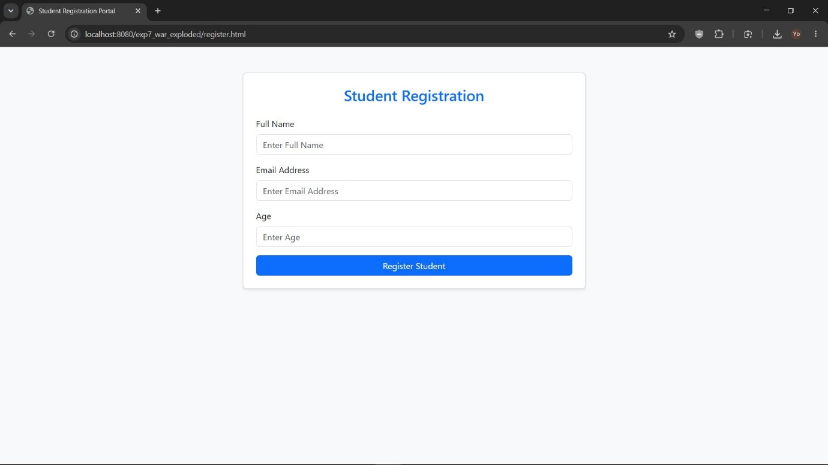

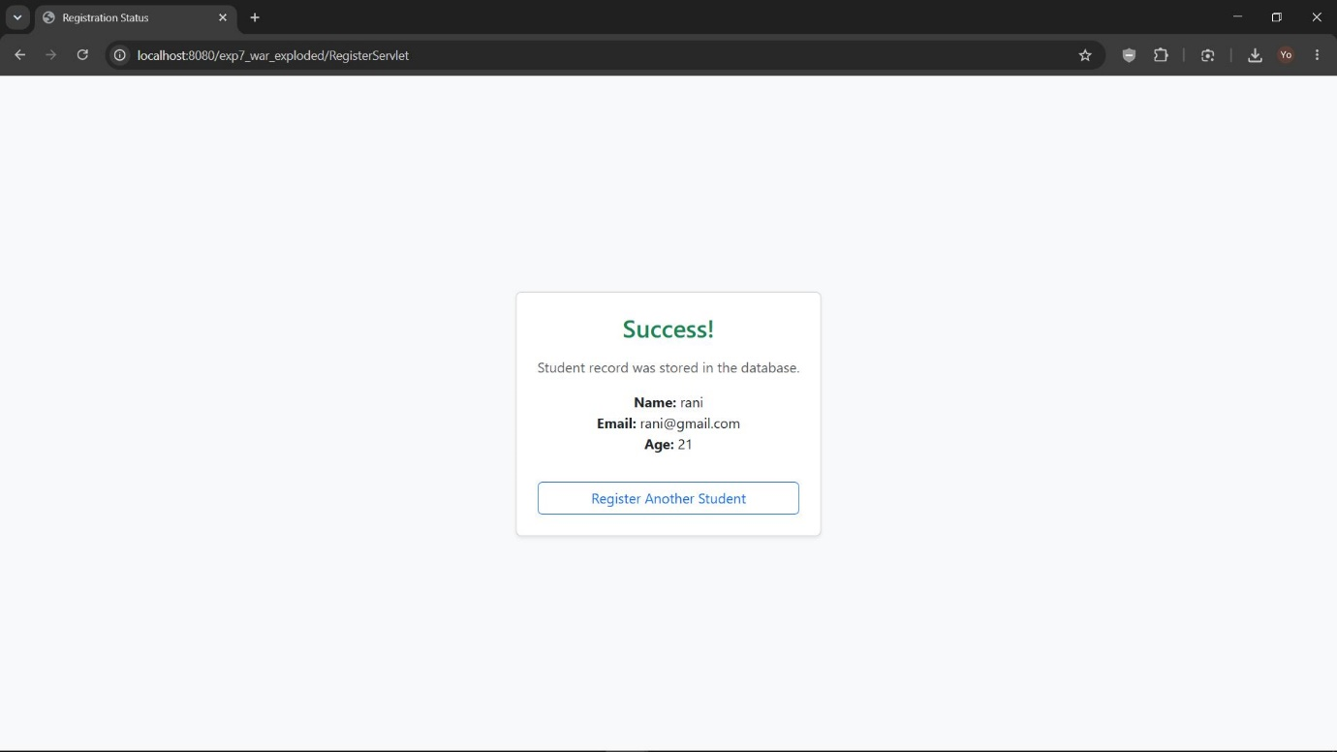

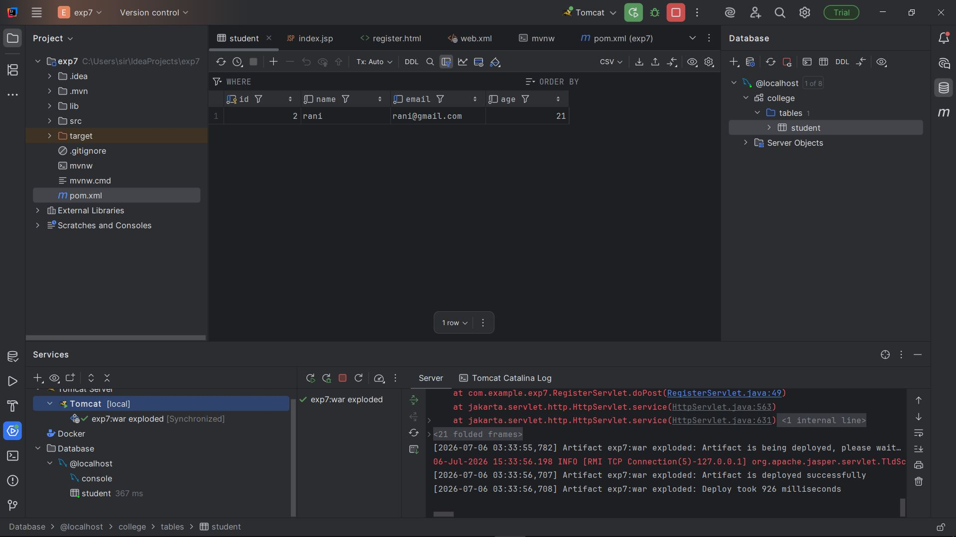

Here is the implementation for Experiment 8, which demonstrates the two main session tracking mechanisms in Jakarta EE: HTTP Sessions and Cookies.
Experiment 8
Objective: Explore the various session tracking mechanisms: Cookies and HTTP Sessions to maintain transactional history or state across multiple pages.

Overview of Session Tracking Mechanisms:
- HTTP Session: Server-side state tracking. The server creates a session object stored in memory and binds a unique session ID (JSESSIONID) to the user.
- Cookies: Client-side state tracking. Small text files sent from the server to the browser, stored locally on the client machine, and sent back with each subsequent request.

1. The Landing Page: session_demo.html
This form accepts a user's name and their preferred layout color theme.

<!DOCTYPE html>
<html lang="en">
<head>
<meta charset="UTF-8">
<meta name="viewport" content="width=device-width, initial-scale=1.0">
<title>Session Tracking Demo</title>
<link href="https://cdn.jsdelivr.net/npm/bootstrap@5.3.0/dist/css/bootstrap.min.css" rel="stylesheet">
</head>
<body class="bg-light">

<div class="container my-5">
<div class="row">
<div class="col-md-5 mx-auto">
<div class="card p-4 shadow-sm bg-white">
<h3 class="text-center mb-4 text-primary">User Session Portal</h3>

<form action="SessionServlet" method="POST">
<div class="mb-3">
<label class="form-label">Username</label>
<input type="text" name="username" class="form-control"
placeholder="Enter Username" required>
</div>
<div class="mb-3">
<label class="form-label">Select UI Theme Preference</label>
<select name="theme" class="form-select">
<option value="light">Light Theme (Gray Background)</option>
<option value="dark">Dark Theme (Dark Blue Background)</option>
</select>
</div>
<button type="submit" class="btn btn-primary w-100">Initialize Session</button>
</form>

</div>
</div>
</div>
</div>

</body>
</html>

SessionServlet.java
package com.example.exp7;

import java.io.IOException;
import jakarta.servlet.ServletException;
import jakarta.servlet.annotation.WebServlet;
import jakarta.servlet.http.Cookie;
import jakarta.servlet.http.HttpServlet;
import jakarta.servlet.http.HttpServletRequest;
import jakarta.servlet.http.HttpServletResponse;
import jakarta.servlet.http.HttpSession;

@WebServlet(name = "SessionServlet", value = "/SessionServlet")
public class SessionServlet extends HttpServlet {
private static final long serialVersionUID = 1L;

@Override
protected void doPost(HttpServletRequest request, HttpServletResponse response)
throws ServletException, IOException {

// 1. Read input parameters
String username = request.getParameter("username");
String theme = request.getParameter("theme");

/* -------------------------------------------------------------
MECHANISM 1: HTTP SESSION (Server-Side Storage)
- Creates a new session if one does not exist.
- Binds 'username' attribute to this session on the server.
------------------------------------------------------------- */
HttpSession session = request.getSession(true);
session.setAttribute("userSessionAttr", username);

/* -------------------------------------------------------------
MECHANISM 2: COOKIES (Client-Side Storage)
- Creates a cookie mapping key 'userThemeCookie' to select value.
- Configures max age duration to 1 day (86400 seconds).
- Adds cookie to response object to save on client's browser.
------------------------------------------------------------- */
Cookie themeCookie = new Cookie("userThemeCookie", theme);
themeCookie.setMaxAge(60 * 60 * 24); // Expiry time: 24 hours
response.addCookie(themeCookie);

// Redirect to ProfileServlet to verify persistent states
response.sendRedirect("ProfileServlet");
}
}

ProfileServlet.java
package com.example.exp7;

import java.io.IOException;
import java.io.PrintWriter;
import jakarta.servlet.ServletException;
import jakarta.servlet.annotation.WebServlet;
import jakarta.servlet.http.Cookie;
import jakarta.servlet.http.HttpServlet;
import jakarta.servlet.http.HttpServletRequest;
import jakarta.servlet.http.HttpServletResponse;
import jakarta.servlet.http.HttpSession;

@WebServlet(name = "ProfileServlet", value = "/ProfileServlet")
public class ProfileServlet extends HttpServlet {
private static final long serialVersionUID = 1L;

@Override
protected void doGet(HttpServletRequest request, HttpServletResponse response)
throws ServletException, IOException {

response.setContentType("text/html;charset=UTF-8");
PrintWriter out = response.getWriter();

/* -------------------------------------------------------------
READING MECHANISM 1: HTTP SESSION
------------------------------------------------------------- */
HttpSession session = request.getSession(false); // Do not create a new session
String loggedUser = null;
if (session != null) {
loggedUser = (String) session.getAttribute("userSessionAttr");
}

/* -------------------------------------------------------------
READING MECHANISM 2: COOKIES
------------------------------------------------------------- */
String activeTheme = "light"; // Default theme
Cookie[] cookies = request.getCookies();
if (cookies != null) {
for (Cookie cookie : cookies) {
if (cookie.getName().equals("userThemeCookie")) {
activeTheme = cookie.getValue();
break;
}
}
}

// Apply theme color based on preference retrieved from Cookie
String bodyBg = activeTheme.equals("dark") ? "#1a252f" : "#f4f6f9";
String cardBg = activeTheme.equals("dark") ? "#2c3e50" : "#ffffff";
String textColor = activeTheme.equals("dark") ? "#ffffff" : "#333333";

// Output HTML response reflecting session states
out.println("<html>");
out.println("<head><title>User Dashboard Profile</title>");
out.println("<link href='https://cdn.jsdelivr.net/npm/bootstrap@5.3.0/dist/css/bootstrap.min.css' rel='stylesheet'>");
out.println("</head>");
out.println("<body style='background-color:" + bodyBg + "; height:100vh;' class='d-flex align-items-center justify-content-center'>");

out.println("<div class='card p-4 text-center shadow-sm' style='max-width:450px; background-color:" + cardBg + "; color:" + textColor + ";'>");

if (loggedUser != null) {
out.println("<h3 class='mb-3'>Dashboard Profile</h3>");
out.println("<p class='fs-5'>Welcome back, <strong>" + loggedUser + "</strong>!</p>");
out.println("<hr style='border-color:" + textColor + ";'>");

// Detailed status print out of tracked session attributes
out.println("<div class='text-start my-3' style='font-size:0.9rem;'>");
out.println("<p><strong>HTTP Session ID:</strong> <code class='text-info'>" + session.getId() + "</code></p>");
out.println("<p><strong>Server-side tracked User:</strong> " + loggedUser + " (From HTTP Session)</p>");
out.println("<p><strong>Browser preference saved:</strong> " + activeTheme + " mode (From Cookie)</p>");
out.println("</div>");
} else {
out.println("<h3 class='text-danger'>Access Denied</h3>");
out.println("<p>No active user session was found. Please log in first.</p>");
}

out.println("<a href='session_demo.html' class='btn btn-primary mt-3'>Sign Out / Reset Demo</a>");
out.println("</div>");

out.println("</body>");
out.println("</html>");

out.close();
}
}
